|  |  |  |  |  |
| --- | --- | --- | --- | --- |
| **Exp.No** | EXNO-5 | | **Name** | P.Thanish Kumar |
| **Date** | 7/09/2021 | **Roll No** | | 19ITL113 |
| **Title** | EB Bill Calculator | | | |

**Aim:**

To Create a EB Bill Calculator.

**Code:**

<!DOCTYPE html>

<html>

<head>

<title>EB Bill Calculator</title>

</head>

<script>

function f0(){

var a= select.item[select.item.selectedIndex].text;

var c_units=document.getElementById("t2").value;

var result;

if(a=="Commercial"){

if(c_units<=100){

result=c_units*0+0;

document.getElementById("ans").innerHTML =("Your Amount Rs: "+result);

}else if(c_units<=200){

result =(100*0)+((c_units-100)*10.50)+20.0;

document.getElementById("ans").innerHTML =("Your Amount Rs: "+result);

}else if(c_units<=500){

result=(100*0)+(100*6.00)+((c_units-200)*13.00)+30;

document.getElementById("ans").innerHTML =("Your Amount Rs: "+result);

}else{

result=(100*0)+(100*3.50)+(300*4.60)+((c_units-500)*15.60)+50;

document.getElementById("ans").innerHTML =("Your Amount Rs: "+result);

}

}

var a= select.item[select.item.selectedIndex].text;

var c_units=document.getElementById("t2").value;

var result;

if(a=="Domestic"){

if(c_units<=100){

result=c_units*0+0;

document.getElementById("ans").innerHTML =("Your Amount Rs: "+result);

}else if(c_units<=200){

result =(100*0)+((c_units-100)*1.50)+20.0;

document.getElementById("ans").innerHTML =("Your Amount Rs: "+result);

}else if(c_units<=500){

result=(100*0)+(100*2.00)+((c_units-200)*3.00)+30;

document.getElementById("ans").innerHTML =("Your Amount Rs: "+result);

}else{

result=(100*0)+(100*3.50)+(300*4.60)+((c_units-500)*6.60)+50;

document.getElementById("ans").innerHTML =("Your Amount Rs: "+result);

}

}

}

</script>

<body>

<br><br>

<section>

<div class="box">

<h4 style="text-align: center; ">EB Bill Calculator</h4>

<br>

<form style="margin-left: 200px;" name="select" >

<table width="80%">

<tr>

<td style="color: rgb(1, 1, 100); font-weight: bold;">Tariff Check</td>

<td> <select name="item" onchange="f0()" >

<option value="Commercial">Commercial</option>

<option value="Domestic">Domestic</option>

</select></td>

</tr>

<tr>

<td style="color: rgb(1, 1, 100); font-weight: bold;">Consumer Units</td>

<td><input type="text" id="t2" placeholder="enter units"> </td>

</tr>

</table>

</form>

<br><br>

<center><button id="btn1" onclick="f0()"> Calculate</button></center>

<br><br><br>

<div class="out">

<p id="ans" style="text-align: center;"></p>

</div>

</section>

</body>

</html>

**Output:**

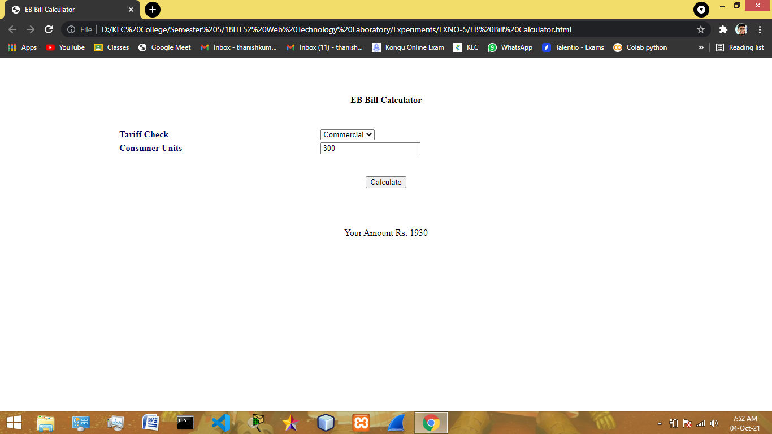

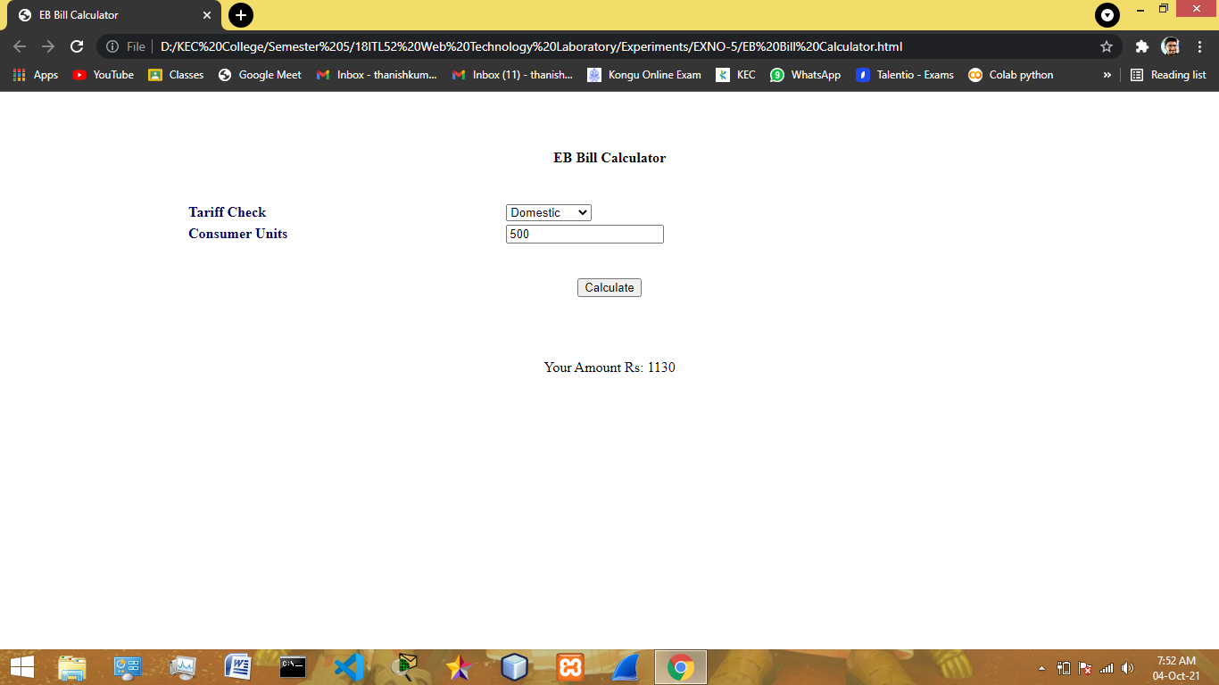

**Result:**

We have created a EB Bill Calculator.